**Project Identification**

|  |  |
| --- | --- |
| **Project:** | **Temporary Workspace Management App Project** |
| **Prepared By:** | Rajesh Bista |
| **Document Version:** | 1.1.0 |
| **Published Date:** | 08/10/2020 |

**Contributors**

The following individuals contributed to this document.

| **Name** | **Title** |
| --- | --- |
| Kamrun Nahar Liza | Product Owner |
| Rajesh Bista | Front End Developer |
| Shishir Das | Quality Analyst |
| Sudeep Manandhar | Scrum master |
| Suvash Sharma | Back End Developer |
| Anjana Shah | Consultant |

**Distribution**

This document is distributed to all the following people.

| **Name** | **Title** |
| --- | --- |
| Anjana Shah | Professor |

**Referenced Documents**

This document refers to the following materials

|  |  |  |  |  |
| --- | --- | --- | --- | --- |
| **Version number** | **Title** | **Author** | **Date** | **Description** |
| 0.2.0 | Project Vision Document | Gr14 Development | 04 Oct 2020 | The requirement analysis |
|  |  |  |  |  |
|  |  |  |  |  |
|  |  |  |  |  |

**Revision History**

|  |  |  |  |
| --- | --- | --- | --- |
| **Version Number** | **Revision Date** | **Summary of Changes** | **Modified by** |
| 0.0.0 | 26 Sept 2020 | First draft prepared | Rajesh Bista |
| 0.1.0 | 01 Oct 2020 | Linguistic edits made | Sudeep Manandhar |
| 0.2.0 | 04 Oct 2020 | Requirement Scope Statements Updated | Shishir Das |
| 1.0.0 | 07 Oct 2020 | Final draft confirmed with team discussion | Sudeep Manandhar |
| 1.1.0 | 14 Oct 2020 | Responsibilities updated, typos edited | Sudeep Manandhar |

[Note: It is recommended that drafts be numbered 0.1 to 0.9, and that the first approved version be numbered 1.0. Thereafter, new version numbers will depend upon changes: 1.01, 1.1, etc for minor updates, 2.0, 3.0 etc for major changes.]

TABLE OF CONTENTS

1. Business Context Diagram 4
2. Requirements Scope Statements 5
3. High Level Business Requirements Sign-Off 5
4. Business Context Diagram

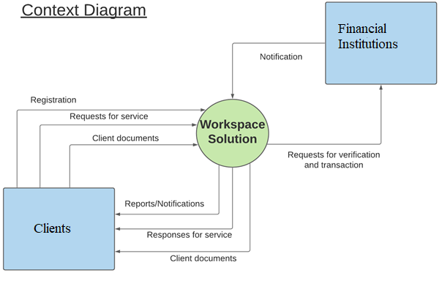

|  |  |
| --- | --- |
| **Requirement Scope Area** | **Description** |
| Workspace Solution | A web application that automatizes the company-client transactions and communications and maintains the required database and supports the clients in finding the suitable space, amenities and services as per their requirement |

|  |  |
| --- | --- |
| **External Entity** | **Description** |
| Client | A company or individual who leases the property on temporary contractual arrangements for official purpose |
| Financial Institution | A financial institution that provides a method of payment for the services rendered to the clients |

| **Information Flows** | **Description** |
| --- | --- |
| Client Documents | Any document in an electronic format that the client can submit, retrieve, upload, download or delete including service rating through Workspace Solution |
| Notification | A notification that is issued:   * Upon successful completion or failure of payment by clients to the TWM company * Upon filing a request by the client * Upon fulfilment of the request by the company |
| Registration | The one-time process of providing the minimum information of a new client required to get online access to Workspace Solution services. |
| Reports | Any documents generated electronically by the company regarding financial transactions, services rendered, maintenance issues, spaces occupied, and requests filed by renters |
| Requests | Requests made by the clients for new and/or customized services, extension of services, maintenance and any other issues or requirements that may arise during their use of space |
| Request for verification of transaction | Requests for verification of information and payment methods pushed forward to respective financial institution the payment process between the client and the company |
| Response for service | Any response given by the company to the client requests |

1. Requirements Scope Statements

|  |  |  |
| --- | --- | --- |
| **HLR#** | **Description** | **Priority**  **(H, M, L)** |
| HLR01 | Clients must be able to arrange and book the meeting, the tour etc | H |
| HLR02 | Clients must be able to view and choose the available rental category and services from list. | H |
| HLR03 | Clients must be able to download and upload the necessary documents in an electronic format. | H |
| HLR04 | Clients must be able to rate the services provided by company. | L |
| HLR05 | Clients must be able to make the online payments for any transactions requiring payments. | H |
| HLR06 | Clients must be able to receive notifications for any information or updates. | M |

1. High Level Business Requirements Sign-Off

The undersigned acknowledge their agreement with the contents of Version 1.0.0 of the High-Level Requirements document for **Temporary Workspace Management App Project**.

Following approval of this document, requirements changes will be governed by the project’s change management process, including impact analysis and appropriate reviews and approvals, under the general control of the Project Plan and according to company policy. Approved Change Request Documents, if present, will be attached to this Requirements Document as updates.

|  |  |  |
| --- | --- | --- |
| **Name** | **Project Role and**  **Functional Area** | **Date Signed** |
| Kamrun Nahar Liza | Product Owner | 07 October 2020 |
| Rajesh Bista | Front End Developer | 07 October 2020 |
| Shishir Das | Quality Analyst | 07 October 2020 |
| Sudeep Manandhar | Scrum master | 07 October 2020 |
| Suvash Sharma | Back End Developer | 07 October 2020 |

* Note: physical signatures are not required. Email approvals are acceptable and should be appended to project documents